Enterprise Infrastructure and Networks – IT-520-A

Mallika Regulla

Marymount University

**Assignment: 1**

1. My internet address is 10.0.0.108 (screenshot below)

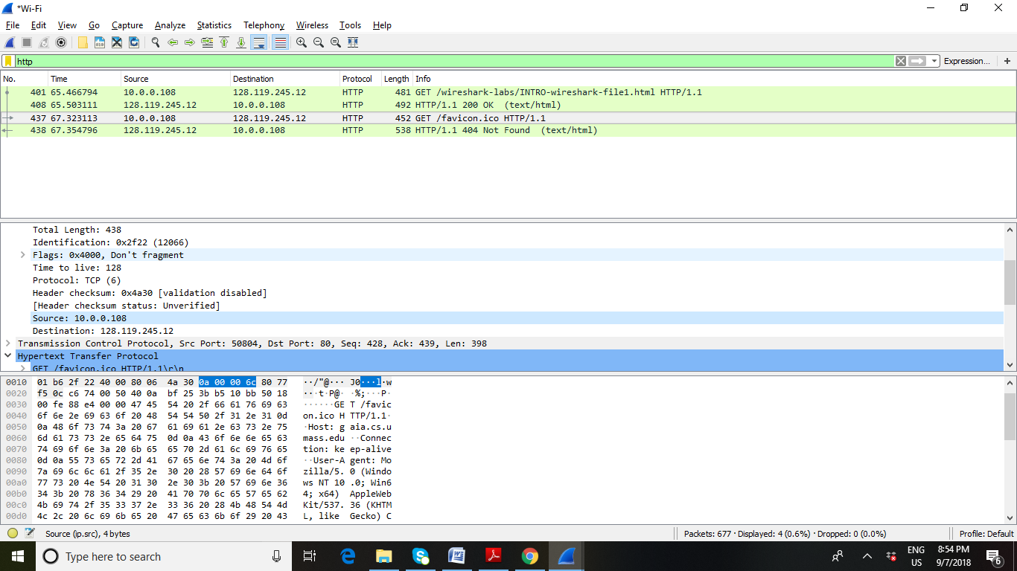

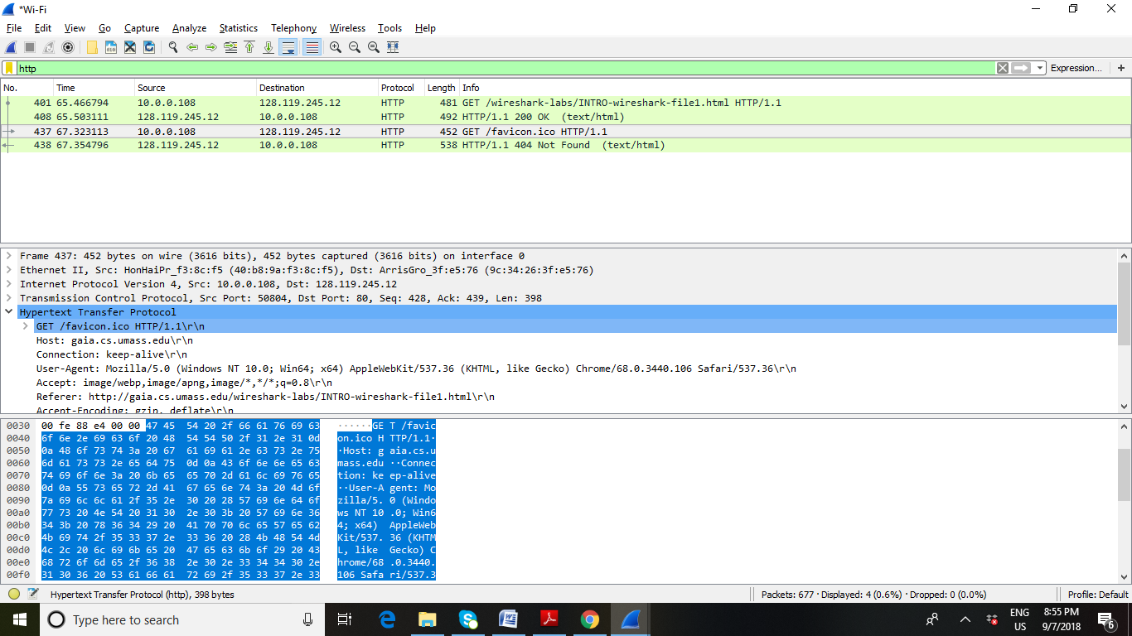

1. Three different protocols
   1. TCP – Transmission Control Protocol
   2. ARP – Address Resolution Protocol
   3. ICMPv6 – Internet Control Message Protocol version 6
   4. SSDP – Simple Service Discovery Protocol
2. Time when GET request was sent = 20:49:24.302052;

Time when OK message was received = 20:49:24.338369;

So the difference between the timeframes is the time it took since the GET message sent and OK message received = 0.036317 seconds

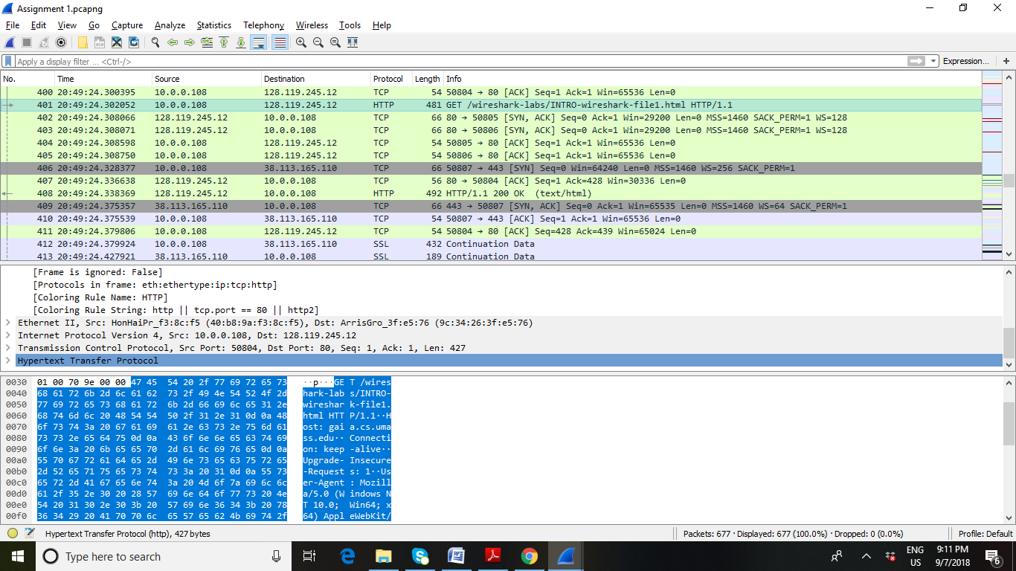

1. Internet address of gaia.cs.umass.edu is 128.119.245.12

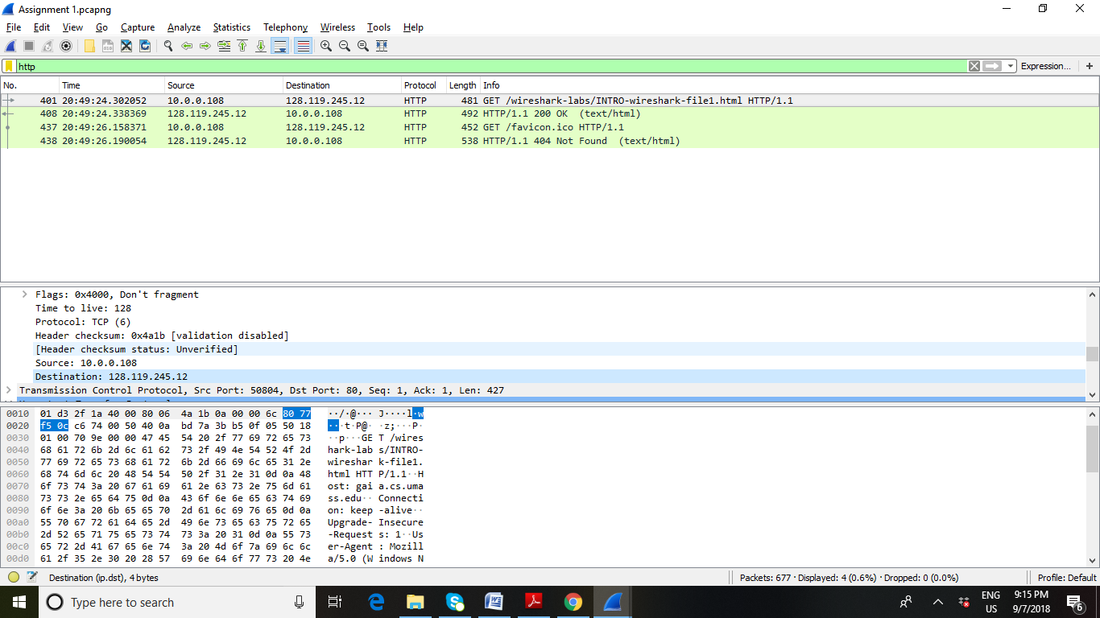

1. Print of GET and OK frames are below. Pdf prints are also attached.
   1. GET Frame



* 1. OK Frame

